# Juran Trilogy- A managerial ideology adopted by company to ensure the needs of customer.

The company makes a product for the customer or offer services to the customer, but what if the customer is not happy? Will the company still grow in the market? The straight answer is "NO". A customer is someone who decides the brand value for a company. For the company to adapt to the situation with changing time, it is necessary to be proactive and innovative to meet the customer requirement. The voice of customer is the prime mover for the company brand value in the market. It is a process in which a company identifies its customer who are going to avail their products or services as well as they should ensure the response of the customer once their products or services launched in market.

But the question is …How can company have a check on the customer?

The simple answer to this is looking for improvement by taking required action:

1. Customer Feedback.
2. Logging Customer complaint.
3. Prioritizing the Customer Demand.
4. Giving Importance to Customer Needs.

A company with good brand name is more trusted by the customers in long terms. As the Quality becomes the base for customer’s trust and support. A company should always look for Improvement and learning.

### “Your most unhappy customer are your greatest source of learning”- Microsoft Supremo Bill Gates

While talking in terms of customer and quality, it would unfair without "Juran Trilogy" because he was the man who highlighted managerial responsibility for the quality and emphasized that quality can be achieved through people rather than techniques. He was the one who considered both the aspects i.e., the management and the technical part involved in quality management. The Quality Trilogy developed by Juran mainly focuses on three parameters i.e., Planning, Control, and improvement.

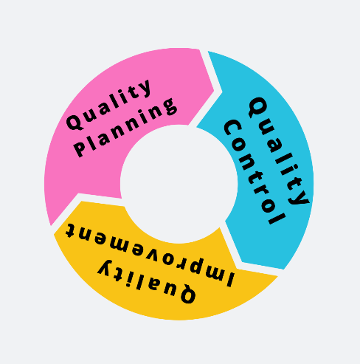

# Quality Planning

The journey of any successful brand name needs a perfect "Planning", the planning done to adhere to the vision, mission, and a goal that a company wants to achieve. Good Quality needs good planning, a plan which involves a route map for achieving legit targets. The plan comprises of:

1. Identifying the set of people in the market who needs your products or services.
2. Determining the needs or the requirements of the customer - Prioritizing the requirements of the customer.
3. Developing the product or customizing the services according to the customer's requirement-
4. Developing the process able to produce that product or service-
5. Optimize the features of the product or add additional services to meet the customer requirement.

Quality planning is something in which a design is created keeping in mind the above-mentioned points. This helps the company in understanding customer expectations or requirements.

# Quality Control

Another parameter is Quality Control, i.e., to design a control process to meet the goals set in the planning stage. It is not only concerned with the improvement in the process but it looks for perfect execution of the process. It follows certain steps to have a quick check for perfect execution of the plan:

1. Selection of the control subject i.e., deciding what needs to be controlled in the process.
2. Select the appropriate unit for the measurement.
3. Setting the standards for the performance and then measuring the actual performance
4. Taking the difference between the standard and the actual performance.
5. To reduce the gap, certain actions needed.

For performing the above-mentioned tasks certain tools are needed to evaluate the whole Quality control process to have legit outcomes. Quality control tools (such as: cause and effect diagram, control charts, etc) are deployed for measuring the performances.

# Quality Improvement

The last and the third parameter is Quality Improvement, which aims at improvising the existing problems being faced during the process or finding a remedy for the poor quality. The steps involved in this particular process are:

1. A continuous check through the process to find opportunities for improvement in the process.
2. Set Goals for the improvement and organize the team to reach the goals.
3. Provide suitable training and resources to the team.
4. Do several projects to solve the problems.
5. Maintain the report for the progress
6. Maintain the momentum of improvement and making an integral part of the whole Quality maintenance system.

A company ensures continuous Quality Improvement as part of the System which helps a company to achieve the targets set in the planning phase. Several Quality tools and techniques are deployed in this improvement process, to maintain the rank of quality.

# The Quality Trilogy Diagram

Juran has also given a diagram where he describes the way to reduce the cost of quality over time. It is a plot between time vs. cost of poor quality.

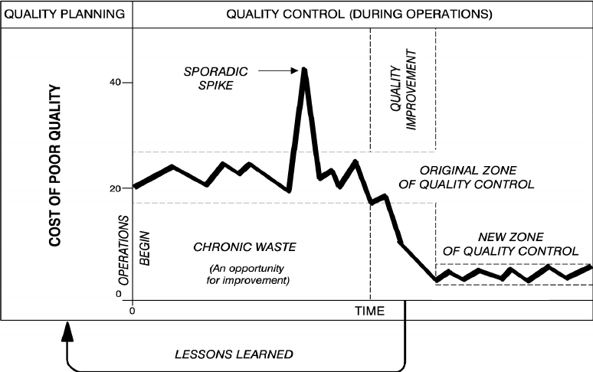

The diagram explains several things that are:

1. The planning phase is the initial phase, before any production process begins, where the ideas of new products or services are designed targeting the set of audiences who will avail these products or services.
2. The operation starts at time t=0, but as the diagram shows that this region will have 20 % defects and Juran calls this region as the region of high defects or the chronic waste region and these defects mostly occur due to poor planning. The company needs to look for the root causes of these defects.
3. If there is a sudden spike in the increase of defects as seen in the diagram i.e., 40% . This spike resulted from some unplanned events such as the sudden breakdown in the system, human errors etc. This spike is called a sporadic spike. These spikes are not favorable for the company.
4. The Quality Improvement is processed and due to these improvements, a new zone of Quality control is seen in the diagram. Now as the percentage of defects decreases to 5% and this reduction is seen due to the Continuous Quality Improvement process. Once the stabilization is achieved the Quality plan need to be updated.

This diagram shows the correct depiction of when to employ the Quality control process and when to employ the Quality Improvement process.

Like when there is an increase in chronic waste due to poor Planning the Quality control parameter is deployed and when the quality control is followed strictly and the sporadic spike is seen then Quality improvement action is initiated to achieve the goals. It is a cyclic process with a continuous improvement approach.

The Quality Trilogy or say Juran Trilogy is followed by the company to maintain the rank of quality which they assure their customers. Therefore before any production process begins perfect planning is done and then once the production starts control or regulatory parameters are deployed and any issues encountered in the process Improvement approach are adopted to solve the issues.

So, for building a good brand value this trilogy is adopted by companies to look for what their customers demand or expect before any new service or product is launched in the market.